Configuration Management Plan for
ECO IT eBusiness Financial Gateway
Customer: Hewlett-Packard Company
GOIT ECO-IT eBusiness IT

 |  | Prepared by:  Shan, Ying  Chen, Yang  Zhu, Liang  Zhu, Lin  Engineer  Project ID No.: SEFG1001  Date Prepared: August 1, 2005

Document Information
Project Name: | ECO IT eBusiness Financial Gateway
Prepared By: | Chen, Yang (TSG-GDCC-SH);  Zhu, Liang (Samio, TSG-GDCC-SH);  Zhu, Lin (Linus,TSG-GDCC-SH);  Shan, Ying (Ying, TSG-GDCC-SH); | Document Version No: | 0.2
Title: | Software Configuration Management Plan | Document Version Date: | April 25, 2006
Reviewed By: | Shan, Ying | Review Date: | April 25, 2006
Distribution List
From | Date | Phone/Fax/Email

To | Action* | Due Date | Phone/Fax/Email
* Action Types: Approve, Review, Inform, File, Action Required, Attend Meeting, Other (please specify)
Document Revision History
Ver. No. | Ver. Date | Prepared By | Reviewed By | Approved By | Affected Section & Summary of Change
0.1 | Aug-1-2005 | Chen, Yang  Zhu, Liang  Zhu, Lin  Shan, Ying | Shan Ying |  | Initial draft base on SCMP of SEFG1001 project
0.2 | April 25, 2006 | Chen, Yang | Shan Ying |  | CM Organization updated, Monthly audit added
0.3 | July 20, 2006 | Chen, Yang |  |  | CM Organization updated, Version control modified
1.0 | Oct 24, 2007 | Chen, Yang | Zhu, Jin |  | CM Organization updated, version control modified

Table of Contents

1. Introduction 4
1.1. Purpose 4
1.2. Scope 4
1.3. Abbreviations and Acronyms 5
1.4. Definitions 5
1.5. References 7
2. Project Overview 7
3. CM Organization 7
3.1. Organization Structure 7
3.2. CM Responsibilities 9
3.3. CM Activities 10
3.3.1. Identifying the Configuration Item (CI) 10
3.3.2. Establish Baseline 10
3.3.3. Naming Conventions 10
3.3.4. Interface Management 11
3.3.5. Directory Structure 12
3.3.6. Change Control 12
3.3.7. Check-in and Check out 16
3.3.8. Access rights 18
3.3.9. Build and Release Management 18
3.3.10. Configuration Audits and Reviews 19
3.3.11. Backup and Disaster Recovery Plan (DRP) 20
3.3.12. Configuration Status Accounting 20
3.3.13. Version Control 20
3.3.14. Document Control and archival 20
3.3.15. Configuration Audits and Reviews 20
4. Appendix – A list of work products that are to be controlled 21

- Introduction
  - Purpose
The purpose of this document is to define the eBusiness Financial Gateway configuration management plan which will support real-time authorization to many credit card processors and enables client applications to integrate effectively with a complete payment and risk management.
This document provide a management process for establishing and maintaining consistency of a product’s performance, functional, and physical attributes with its requirements, design and operational information throughout its life.
  - Scope
The configuration management activities defined in this plan shall apply during the
development of eBusiness Financial Gateway and during its maintenance phase.

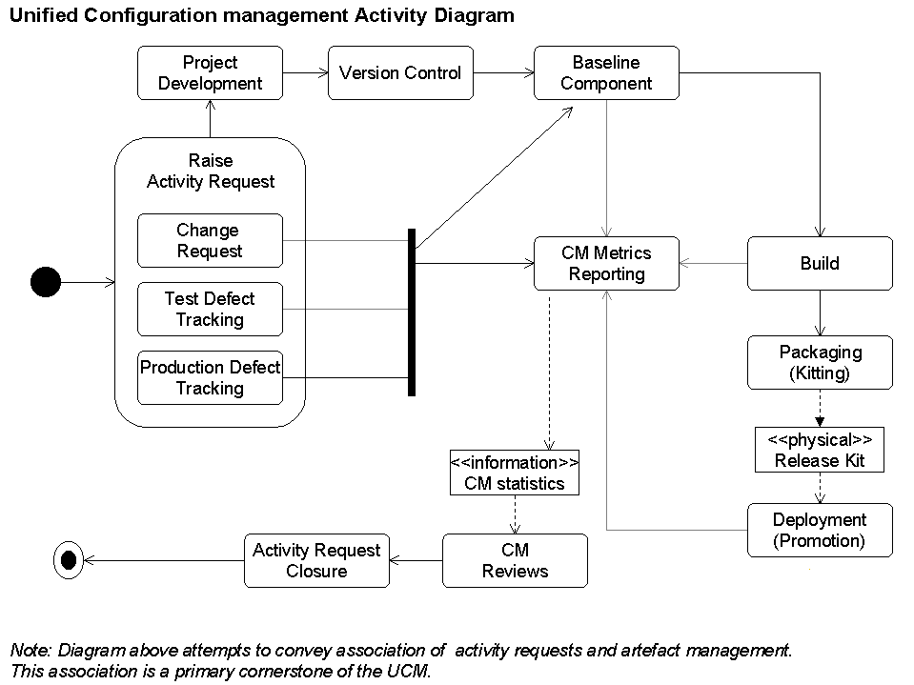

  - Abbreviations and Acronyms

Acronym Meaning

CCB Configuration Control Board
CI(s) Configuration Item(s)
CM Configuration Management
CMP Configuration Management Plan
CR(s) Change Request(s)
CRF Change Request Form
TR Test Report
ITS Issue Tracking System
DRP Backup and Disaster Recovery Plan
FGW Financial Gateway
RTM Requirements Traceability Matrix
PMR Project Management Review
IQMS Integrated Quality Management System
SQA Software Quality Assurance
SQM Software Quality Management
SCM Software Configuration Management

  - Definitions

We define Configuration Management as four primary activities.
- Identification
- Management
- Status Accounting
- Audit

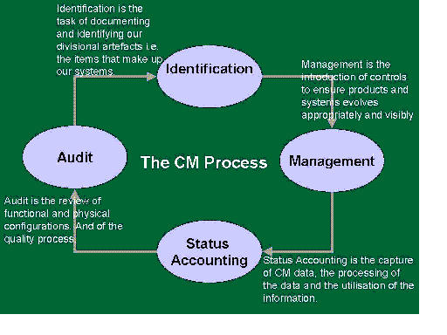

Configuration Item. | A Configuration item is a collection of software elements that is treated as a unit for the purpose of configuration management. These software elements/work products can be modifiable entities such as source code; customer supplied items; test data; documents or can be support software such as compilers or test tools.
Software Configuration Management | Software Configuration Management is the process of identifying and defining the configuration items in a system, controlling the release and change of these items throughout the system life cycle, recording the status of the CIs and change requests, and verifying the completeness and correctness of the CIs.
Baseline | A specification or product that has been formally reviewed and agreed upon, and thereafter serves as the basis for further development, and can be changed only through formal change control procedures. An item must be brought under Configuration Management if it is to be part of a baseline. Each member of a Baseline is assigned a documented identifier (tag).
Configuration Status Accounting | It is the recording and reporting of the information that is needed to manage a project repository effectively; includes listing of the approved configuration identification, the status of proposed changes, and the implementation status of approved changes.
Configuration Audit | It is the process of verifying that configuration items have been produced, and that the current version is consistent with the agreed requirements and change requests documented as having been incorporated therein.

-
  - References
Documents list
- Payment Gateway 2.1 Design.doc
- Payment Gateway Technical User Guide V2.0.doc
- RM_Developers_Guide_20050506.pdf
- RM_Installation_Guide_20031017.pdf
- RM_Users_Guide_20031022.pdf
- Project Overview
The solution incorporates all aspects of the financial lifecycle for credit card processing; it supports real-time authorization to many credit card processors and enables client applications to integrate effectively with a complete payment and risk management.

- CM Organization
  - Organization Structure

Customer
CCB/PM’s Repoting Manager

Customer Contact
PM
CM Lead

Team members

Role | Name
SCCB | Ji, Li-Chun
SCM Owner | Chen, Yang
Project Lead | Ji, Li-Chun
Project Manager | Ji, Li-Chun
Section Manager | Xu, Jin-Shui
Project SQA | Zhu, Jin
SCM Administrator | Chen, Yang
Team members | Chen, Yang  Ji, Li-Chun  Lai, Fei  Shen, Lin  Shui, Tain-Yi  Wang, Shu-Wen  Wu, Zhao-Ming  Yuan, Hong  Zhang, Dong  Zhu, Jin

  - CM Responsibilities

Role | Responsibilities
Customer | - Review the SCMP, if required
Project Team | - Helps define the SCM processes  - Follows the SCM procedures as outlined in the SCM Plan  - Owns the configuration items  - Takes the ownership to correct deviations observed in audits
SCM Owner | - Generates the SCM plan.  - Owns the project's SCM activities  - Responsible for SCM implementation and maintenance  - Ensures that changes to configuration items are validated and conducts audits.  - Maintins SCM baseline change records  - Responsible for defining changes in the SCM as product deliverables change, with inputs from project team.
Project Lead | - Ensures integration of SCM activities into project schedule.  - Helps define the SCM processes  - Leads and coordinates SCM planning with the project's SCM Owner and the rest of the project team  - Receives documented deviations in audits.  - Participates in identifying corrective actions and tracks corrective actions to closure
Project Manager | - Reviews SCM plan to ensure the availability of resources, tools equipment and schedule for SCM activities.  - Ensures that SCM activities are integrated into the overall project schedule plan.  - Reviews reports documenting SCM activities and software baseline content.  - Escalates any SCM issues to Senior Management if these issues can't be resolved within the project.
Project SQA | - Reviews SCM activities
Org SQA | - Audits SCM activities
Software Configuration Control Board (SCCB) | - Responsible for managing Software baselines  - Authorizes the establishment of Software baselines  - Reviews and authorizes changes to Software baselines  - Authorizes creation of products from the SCM repository
SCM Administrator | - Provides expert inputs and assistance for solving problems relating to SCM tool  - Responsible for tracking and renewing licenses for SCM tool.  - Responsible for backing up the SCM tool data.

  - CM Activities
    - Identifying the Configuration Item (CI)
No | Item Code | Item Name & description | Type of item  (files –code /Documents) | Owner | Originating baseline
1 | HLD,LLD | Software Design document (HLD and LLD) | Documents | PGS team | Allocated baseline
2 | SC | Source Code, including Make files and data files | Report for Files-code | PGS team | Product baseline
3 | TP,TC | Test plans and test cases | Report Files-code | PGS team | Functional baseline
4 | UM | Any other project documents like User manual etc. | Documents | PGS team | Functional baseline
    - Establish Baseline
Phases | Baseline
Requirements definition. | Functional baseline
SRS, Interface spec. | Functional baseline
Detailed design | Allocated baseline
Source and Object code | Design baseline
User manuals | Product baseline
Test documents | Product baseline

    - Naming Conventions
- File naming Conventions
- Document Naming Conventions

CI Description | Files (Code…) | Document Types
RS | Requirement Specification | Document
HLD | High Level Design | Document
LLD | Low Level Design | Document
TP | Test Plan | Document
TC | Test Case | Document
M | Module X | File-code
UM | User Manual | Document

Naming Conventions as a practice its better to have uniform naming conventions across project for unique identification of CIs link Naming Conventions Guidelines - <Guidelines for CM Activities Doc>

    - Interface Management
A comprehensive set of interfacing procedures has been developed to ensure that the respective elements of the facility interface, connect, and operate properly when they are installed at the site. These procedures provide a detailed technical description of the interfacing components of the facility. A list of these design requirements documents is listed in Section 1.5 (Payment Gateway 2.1 Design.doc / Payment Gateway Technical User Guide V2.0.doc) this set of interfacing documents, along with project management practices, establishes the means for coordination between the respective design entities. The procedures will allow the design and construction of the facility to proceed at an optimum cost and schedule.
    - Directory Structure
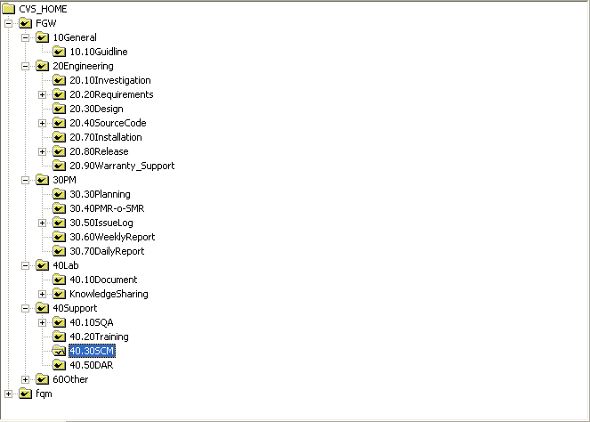

    - Change Control

Change control is a mechanism for controlling changes to the CIs, including details of initiation, recording, analysis, approval, implementation, tracking and closure. There can be more than one change control procedure for different types of CIs.
a) Change Control procedure for codes:
Change Control should be strictly followed after formal baseline. Usually change control begins with Change Request. This could include how the change request can be:
- Initiated – who can initiate and how?
- Recorded – where the change request is stored?
- analyzed - who analyzes the request and what is the outcome of the analysis ( impact, feasibility)
- Approved – who is the approval authority for implementing changes to baselined items. If there is a SCCB (Software Configuration Control Board) doing this, mention their role here.
- Implemented – who implements the changes and what is the procedure used. If a tool is used for check-in and checkout of a CI from the baseline, then describe the tool-specific steps involved in adding, deleting and retrieving the CIs. If there are multiple sites of development, explain how synchronization and merging happens and what access controls are taken to avoid erroneous update to any CI.
- Closed - describe the closure process after implementation to ensure that changes have not caused unintended effects on the baseline. This can be achieved through reviews, regression tests, approval from SCCB etc., Also take care to update the Requirements Traceability Matrix (RTM) wherever necessary to maintain traceability of the configuration throughout the software lifecycle
- Tracked – describe the process of tracking the change requests and their status
The status of change request can be tracked with the ITS (Issue Tracking System) tool. (Refer to the ITS tools usage.)
Initiated
Recorded
Analyzed
approved
Implemented
Closed
Submit
Assigned
Resolved
Closed
ITS status changes

b) Change control procedure for requirement changes (requested by customer or project team)
Usually the requirement change control follows more strict procedures:
  - Open: When a Change Request is issued through Change Request Form (CRF), following information should be included: Change Report Number, Initiation Date, Priority, Initiator Name, Position, Organization, Date Response Required, Description of Change, Reason of Change, Type of Response Required.
  - Investigation: PM and PL will arrange an investigation to find out the impact of the change to the project, and fill certain investigation information to the Change Request Form (including summary of investigation, Quality Impact, Schedule Impact, Effort/Cost Impact, Resource Impact, Reference/Attachments and Recommendations)
  - Evaluation: Both PM and PL in the project team and authorized customer representative in SCCB will evaluate the change request and give their recommendation respectively. There maybe another party also gives their recommendation as evaluation output.
  - Approval: Once agreement has been achieved, both PM of the project team and authorized customer representative in SCCB will sign to approve the Change Request.
  - Accepted: Once the CR is approved, project team will assign the CR to related person and make out an action plan for implementing the Change Request.
  - Development: SCM Owner will create proper views and change request branch for developers who will work on the Change Request to let them access and check out correct baseline versions of the project artifacts for implementing the Change Request. The action plan status should be tracked to close using the Change Request Form.
  - Validated: After a Change Request is implemented and tested; the versions with Change Request should be baselined and merged back to the integration branch for integration testing and further to system testing branch for system testing. The resolution should be recorded in the Change Request Form.
  - Delivered: After PM’s approval, the Change Request implementing versions will be merged to release branch and released to customer by SCM Owner. The customer’s purchase order number for the Change Request should be recorded in the Change Request Form if applicable.
  - Tracked: A change log will be maintained to track the status of all the change requests in the project. The Change Log includes following information: Change Request No., Description, Initiator, Initiation Date, Effort, Status, Status Date, Status Notes, Target Close Date.

The status of change request can also be tracked with the ITS (Issue Tracking System) tool.
SCCB
Approve
Make action plan
Evaluate and give recommendation
Baseline and Release from the Release Branch
Customer
Issue Change Request thru CRF
Investigate and analyze impacts
Create CR branch and set view for developers
Implement CR and Unit Test, Integration Test
Merge and build for System Testing
System Testing
SCM
PM
Project Team
Test Team

Initiated – who can initiate and how?

Recorded – where the change request is stored?

Analyzed - who analyzes the request and what is the outcome of the analysis (impact, feasibility)

Approved – who is the approval authority for implementing changes to baselined items. If there is a SCCB (Software Configuration Control Board) doing this, mention their role here.

Implemented – who implements the changes and what is the procedure used. If a tool is used for check-in and checkout of a CI from the baseline, then describe the tool-specific steps involved in adding, deleting and retrieving the CIs. If there are multiple sites of development, explain how synchronization and merging happens and what access controls are taken to avoid erroneous update to any CI.

Closed - describe the closure process after implementation to ensure that changes have not caused unintended effects on the baseline. This can be achieved through reviews, regression tests, approval from SCCB etc., Also take care to update the Requirements Traceability Matrix (RTM) wherever necessary to maintain traceability of the configuration throughout the software lifecycle

Tracked – describe the process of tracking the change requests and their status

    - Check-in and Check out

Creating a Repository
- Identify the necessity to create a new repository in consultation with team leads.
- Select the repository name according to SCM guideline naming policy.
- Get the approval from Project manager.
- Create the repository in SCM tool. Create a module named “FGW” for the project.
- Set the directory permission according to the team’s requirement.

Help user to setup the SCM tool and configure it
All Team members will install the SCM tool client with the help of SCM owner.
- Setup the SCM tool Client, i.e. WinCVS client.
- Configure the tool and make sure it can access the repository

Checkout and Check in files
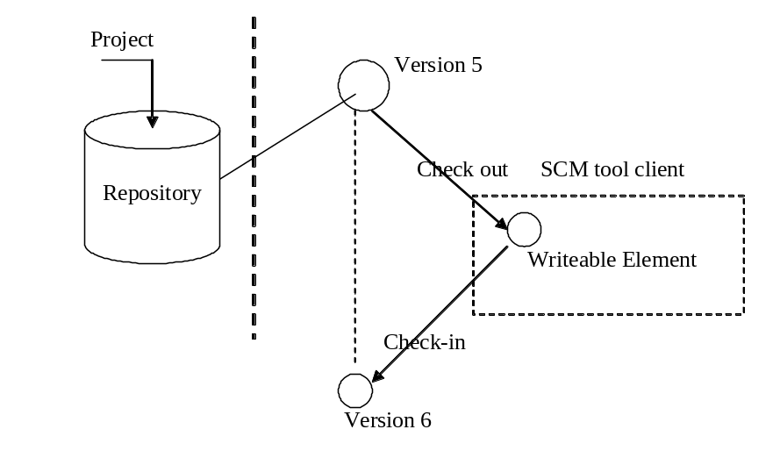
- check out and check in file

A File element cannot be modified unless you check it out, in CVS, use “cvs edit … ” command. After the file be checked out, it can be modified and check in to repository as a new version.

While check in or add an element:
- Add suitable comment, e.g. specify the defect No. fixed or CR implemented. SCM owner can configure the server to force it. Thus, if the user doesn’t add comment, it will cause the checking in failure.
- Make sure the files and directories name suit the naming convention. This also can be checked automatically by configure the server.
- Make sure you are working in the correct branch. If you use CVS, make sure you set correct “stick option”

Add/delete files
User can add/delete the files.
- All add/delete files operation should be logged.
- Make sure the deleted files can be found again. In CVS, we can find deleted files from directory “Attic” in CVS server side.
- Make sure not delete the CIs in the SCM repository permanently. Please contact the SCM owner if you have sufficient reason to permanently delete a CI.

Merge files
Some SCM tool can merge the text file automatically when the following process occurs. CVS support automatic merge function. In some cases, the modification of two users’ conflict, the responsible users should work together to check and modify the merge result to make sure the merge result is functionally correct.
A check it out
B check it out
A check it in
B also check it in
Merge occur here
Time
- CVS Merge process

    - Access rights

Description | Read only | Write
Controlled | CM-L,PM | CM-L
Dynamic | CML,PM,TM | CML,PM,TM
Static /Back up | CM-L,PM | CM-L
Release | CM-L,PM | CM-L
    - Build and Release Management

The build procedure should be specified at the project level.
- The software baselines to be used for building the product deliverables
- The persons who authorizes creation of products from the baselines (This group constitutes the SCCB for any new product build)
- The persons responsible for building
- The build tools/environments
- The specific steps that must be used to build the work products
- The validation steps to ensure correct versions of the software are considered for building.(There can be a planned SCM audit to verify the integrity of the baseline)
- Criteria for a successful build

Release Procedure
- Team Member completes the testing.
- SCCB(PM/PL) approve and initiate the release.
- SCM create release baseline.
- Project leader and developer verify it base on the release baseline tag.
- Team Member and PL write the release notes.
- SCM owner do the release baseline audit and create the report.
- SQA Check the release and give out report.
- PL checks the release and fills the release checklist.
- Internal Sign off.
- Communicate with customer and perform the delivery.
- Customer signs off.

Team Member
SCCB
SCM
Customer
SQA
Testing Complete
Release
Approved
Release
Baseline
Verify Baseline (testing)
Release Notes
SCM
Audit
SQA
Check
Release Checklist
Internal Sign off
Delivery
Customer Sign off

- Release Procedure

Release Check
- SQA Check: Ensure it meet the quality goal --- according to the release checklist
- SCM Audit: FCA/PCA --- According to the Audit checklist
- PL/SCM owner check: All the things --- According to the release checklist

Release checklist: please refer to the appendix at the end of this document.

Release Criteria
- Zero outstanding system defect.
- Functions fully tested and met the requirements.

    - Configuration Audits and Reviews
CM Audit No | Frequency of Audit (Phase wise/Milestone) | Date of Audit
 | During Baseline
 | Periodic Audits fitted with SDLC adopted by team

< Each Planned CM Audit should be conducted as per frequency and the Audit report should tracked in Project Management Review (PMR)>

Refer CM Audit Report template and Guidelines for CM Activities
    - Backup and Disaster Recovery Plan (DRP)
Backup Plan: Describe the backup and recovery mechanism to be followed for the project.

Back up frequency | Location | Date
At every baseline | Houston
Weekly(in accordance with ITMB cm frequency) | Shanghai ITMB

Disaster Recovery Plan (DRP): Prepare DRP for the project.

.
    - Configuration Status Accounting
CI Status Recording & reporting
- Proposed: a change request is proposed
- Implemented: a change request has been implemented
- Accepted: a change request was accepted
- Interrupted: a change request was interrupted while being implemented but not complete
- Released: CIs have been released
- <Summary of status on the relevant CIs ,change requests, changes made to the baselines and Revision history of CIs > Refer <CI Status accounting report template, CM Audit Report>

If Tool used for generate the CI status reporting mention the tool.

    - Version Control
Version control system controlled and administrated by our client. When a product is released, a proper version will be given by our client, at the same time, the source code and related documents in China will be tagged/labeled the same version, for informal version control, just follow the CVS version control rules and related tools.
    - Document Control and archival
- mechanism for control documents: any change of documents should be confirmed by Project Leader or CM Leader
- retention period and the a archive of the documents are in accordance with organization rules

    - Configuration Audits and Reviews
CM Audit No | Frequency of Audit (Phase wise/Milestone) | Date of Audit
1 | Monthly | April 25, 2006
2 | Monthly | June 5, 2006
3 | Monthly | June 27, 2006

- Appendix – A list of work products that are to be controlled
Release Checklist:

Activity | Status | Remarks
Testing of the release software
Does the release software contain the latest code?
Has the SCM/release team baselined the code?
Has the software been unit tested?
Has the software undergone integration testing?
Has the software undergone installation testing?
Was the software tested on all supported platforms?
Is the system test report created and archived?
Reviews/Audit
Has this version of the product undergone formal review?
Has there been an SCM audit to check the versions of the files?
Were there any comments during the review or audit and are these comments closed?
Are the SCM audit / Release audit report created and archived?
Bugs/Bug-Fix Release
Are there any showstopper bugs?
If this release is a bug fix release, is the name id and description of the bug fixed included in the release notes?
Was the bug fix tested on all supported platforms?
Are the bugs discovered during the testing stage reported on the bugs capturing tool?(Chart/Bugzilla)
Content of the release package
Does the release package contain the following:
SOW
Requirement document
System Test plan & case, selected migration investigation reports.
Design documents
Source code / unit test report
System Test Report
Installation package, Deployment guide, Contingency plan
Does the release note follow the prescribed template?
Does the release note contain the complete list of files bundled with the release along with their version numbers?
Is the Requirements Traceability Matrix (RTM) complete?
Has the management approved the release?
Are all the release criteria met?
Is the quality report created and archived?
Post Release
Is a check done on the access of the released software?
(e.g.: If the mode of release is “http download”, was the “http download” tried separately Or if the mode of release was a CD, was the installation tried afresh from the CD)
Was the communication done about the release to the responsible people awaiting the release?
Has a post release meeting been planned?

